On Top of Site,

1st Carousel picture

Verbage:

**Welcome to**

**Foundations in Creation**

**& 242 Ministries website**

We have a passion for helping seekers discover answers, equipping the saints, & encouraging the body of Christ. Please take a look around and contact us to let us know how we can assist you on your journey of discovery!

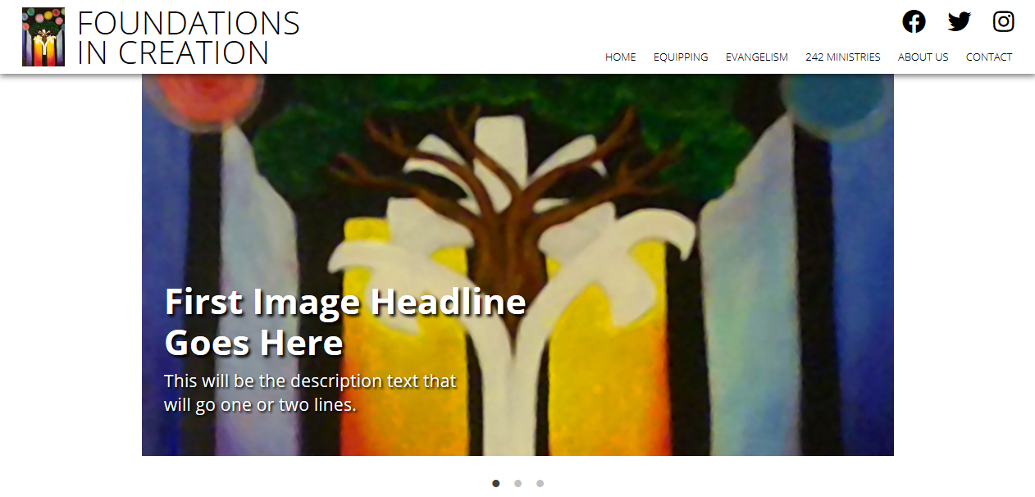

2nd Carousel:

Verbage:

3rd Carousel:

Can we move the “About Us” section to right below the Carousel Top slides?

But leave the “Contact Us” section at the very end… Or duplicate it at the end?

Also, please delete the line from this section:

Their teachings have covered such topics as:

***“Twelve Biggest Lies”*** – used as sermon series for Sunday mornings

***“Unlocking the Mysteries of Genesis”*** – used as Earth Science and Small Group curriculum

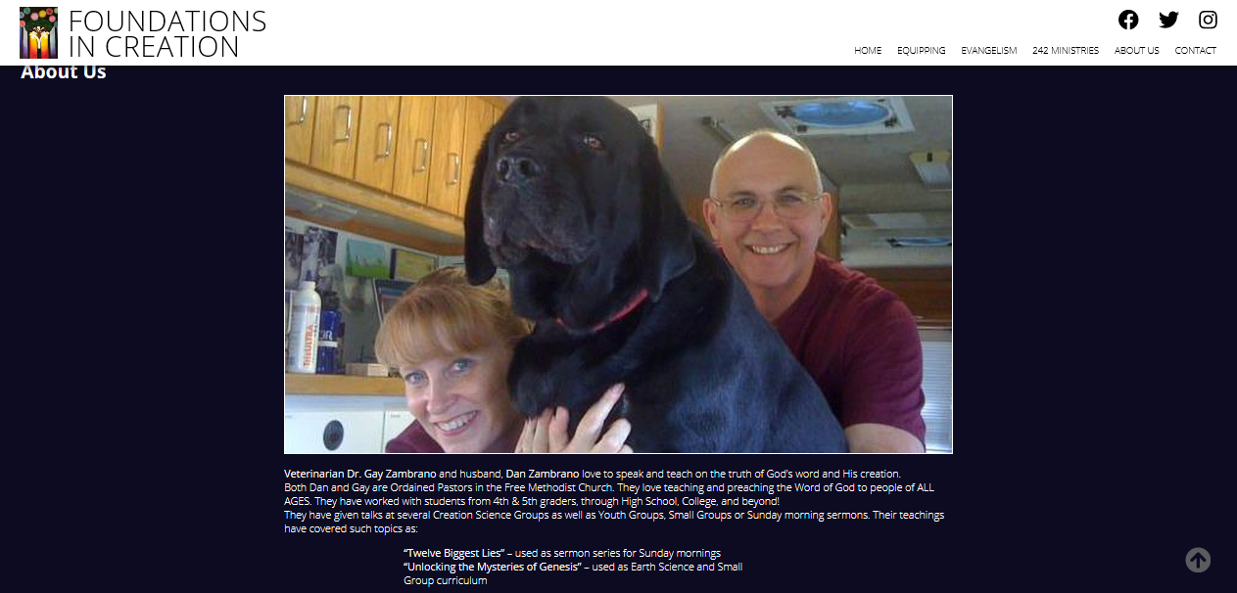

242 Ministries Section

Replace the Large photo {Rescue Mission Chapel} with this one:

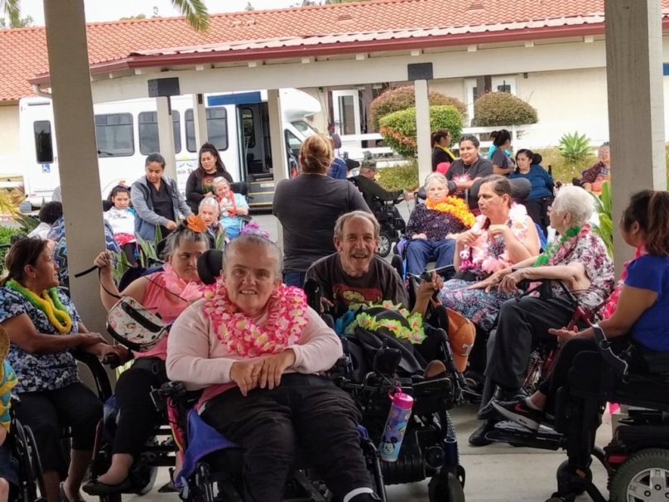

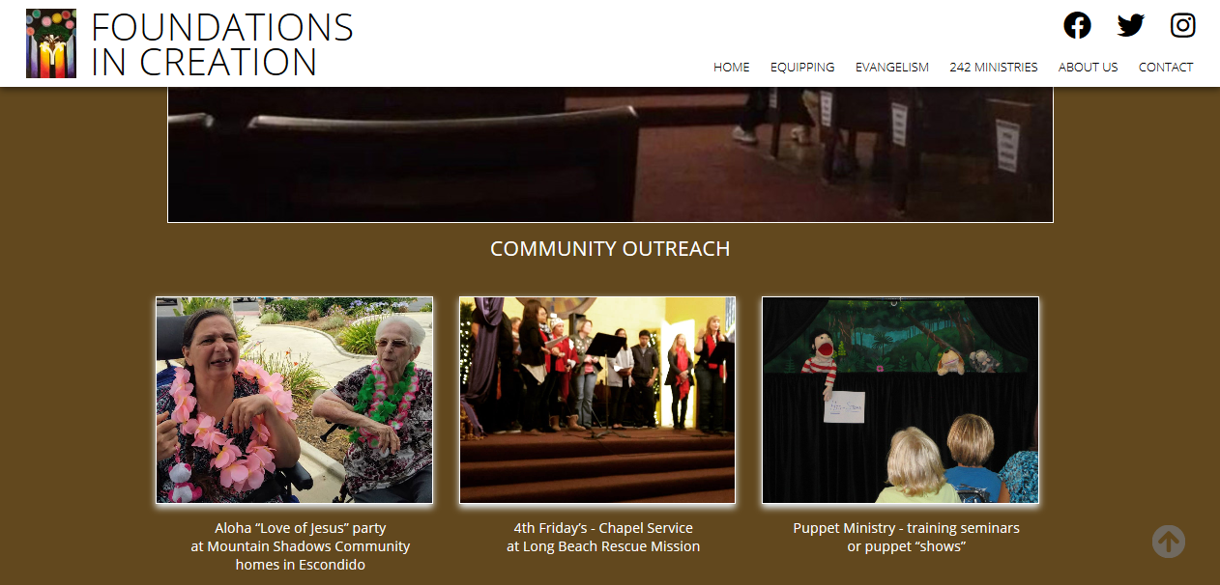

Replace the photo on the left (Carol & Diana) with this one.

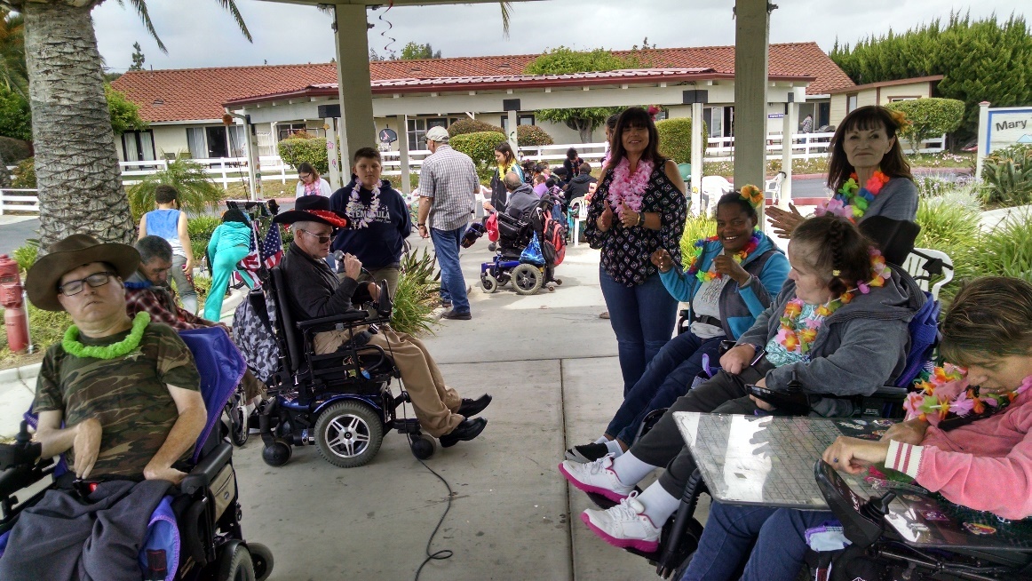

Replace the middle photo – Long Beach Rescue Mission - with this one

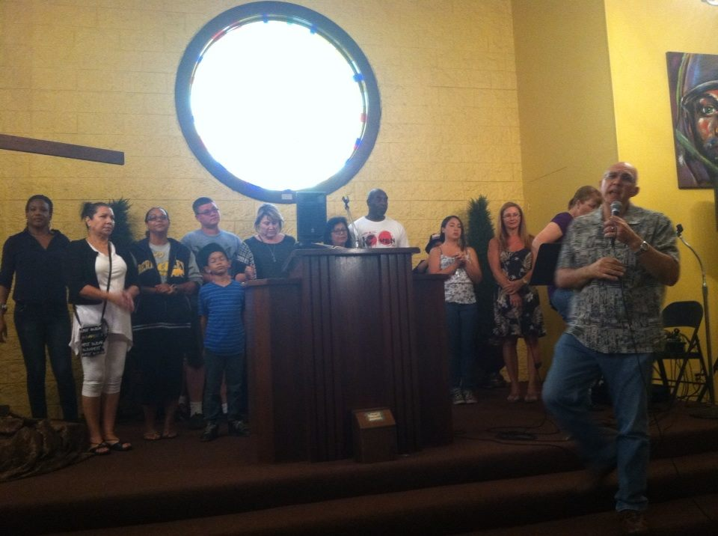

CAN WE ADD A SUBSECTION under “Creation Science Based Courses & Seminars”

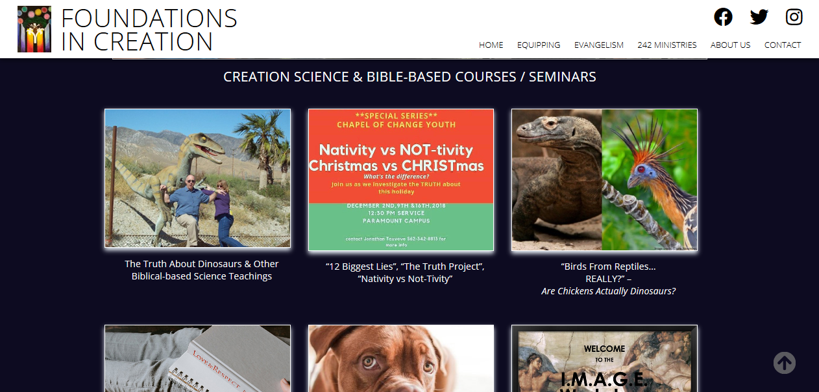

GO further Down and ADD SECTION called:

**“LEADERSHIP DISCOVERY, TEAM, & RELATIONSHIP BUILDING COURSES”**

Put the following thumbnails in the new section:

Nativity vs Not-tivity

Image Workshops

Pre-marital Counseling

Digital Zombies